Traduction sponsored by :

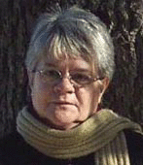

Hélène Degoix, from Forcalquier, France ( ixchel04@wanadoo.fr )

Alexis Faure, from Paris, France ( the_last_dragon_tears@ifrance.com )

Jean-Pierre Petit, from Pertuis, France and :

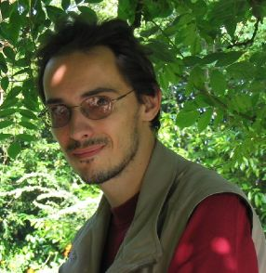

José Bray jarjarjojo@free.fr, France

